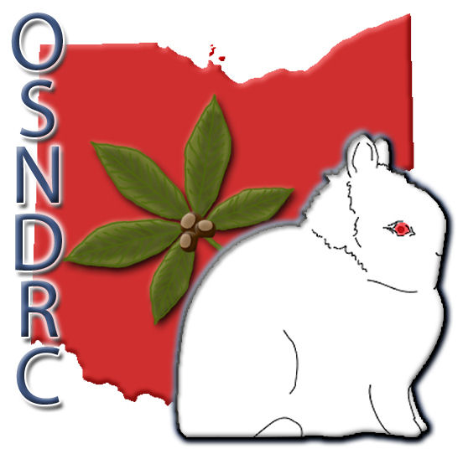
SANCTION REQUEST
for the
Ohio State Netherland Dwarf Rabbit Club (OSNDRC)

Sponsoring Club:
Location:
Show Date:
ARBA Open Sanction #:
ARBA Youth Sanction#:
Show Secretary:
Mailing Address:
City: ST: Zip:
Phone: ( ) -
E-mail:
Does your club use computer print-out results? ( ) YES ( ) NO

SANCTION FEE OPEN $6.00. YOUTH $2.00

SEND SANCTION REQUESTS TO:

Ohio State Netherland Dwarf Rabbit Club
TINA DAILEY
OFFICE USE ONLY
Date Application Rec’d:
Date Approved:
Amount Rec’d:
Check #:
Reports Rec’d:
Comments:

8100 CHAMBERSBURG ROAD
HUBER HEIGHTS, OH 45424

ALL SANCTION REQUESTS MUST BE RECEIVED NO LATER THAN 30 DAYS PRIOR TO SHOW DATE.

If you have questions, please email Tina Dailey
Dailey.tm11@gmail.com

